TRADER (PHP)

1. First, you need to go to the **homepage** of Nature’s Fresh Mart and then you can find **LOGIN** button at the navigation bar.

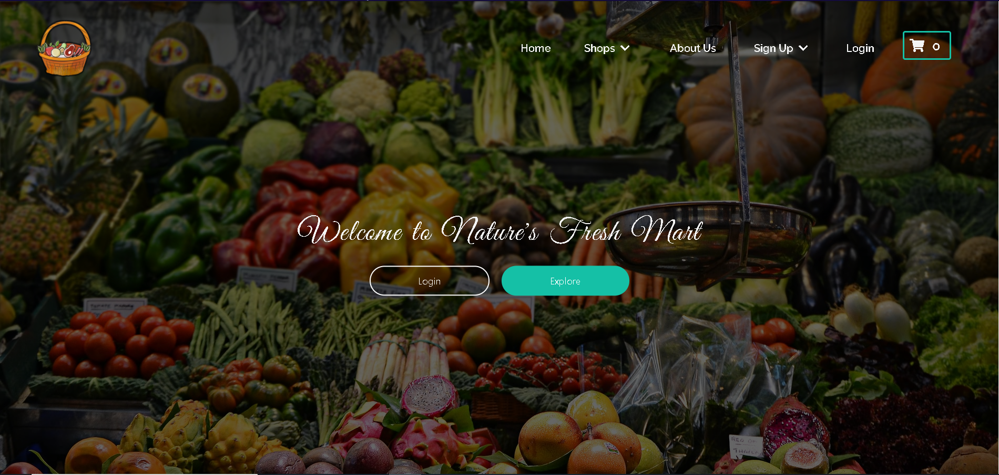

1. Then in the **Login page**, choose trader as your user type and login using your valid credentials you will be directed to homepage

Username

[neplese931@gmail.com](mailto:neplese931@gmail.com)

Password

Saugat123

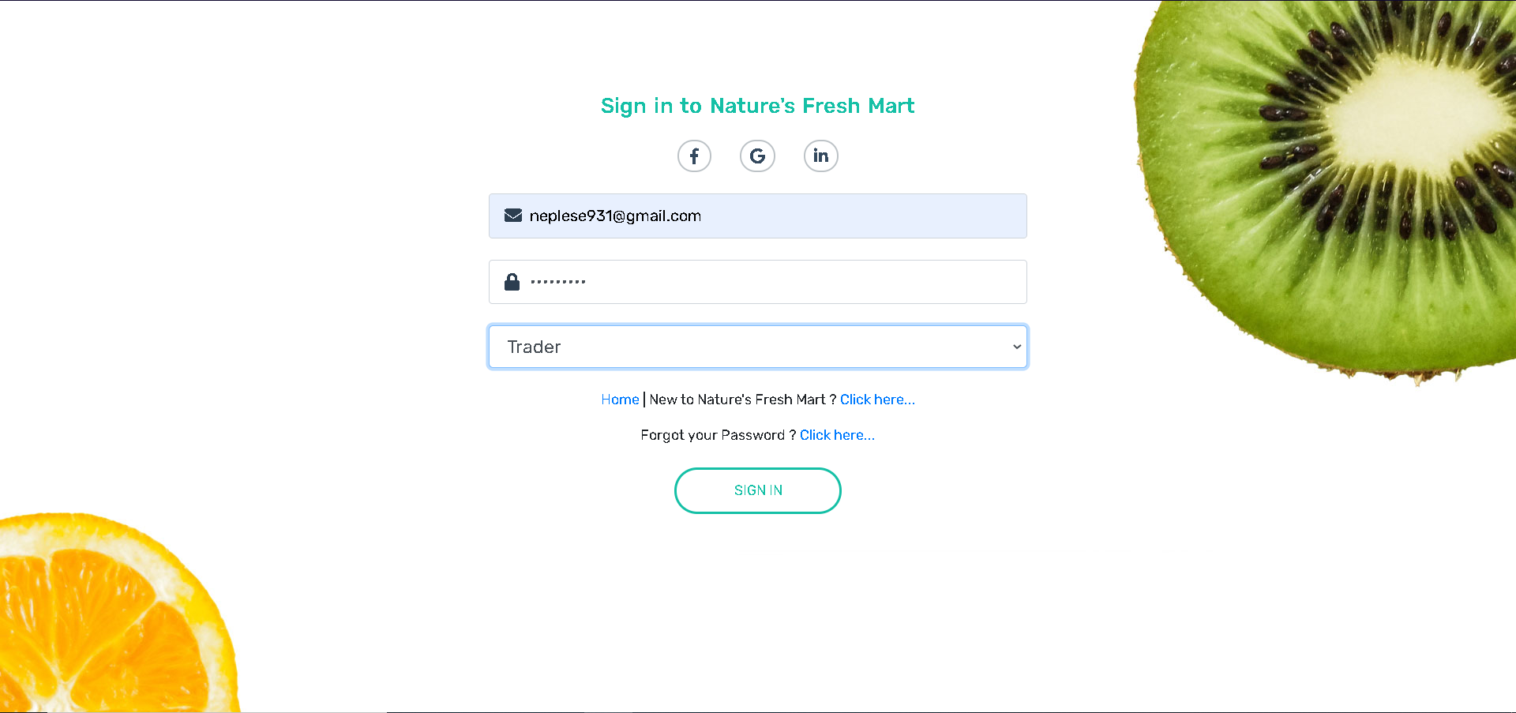

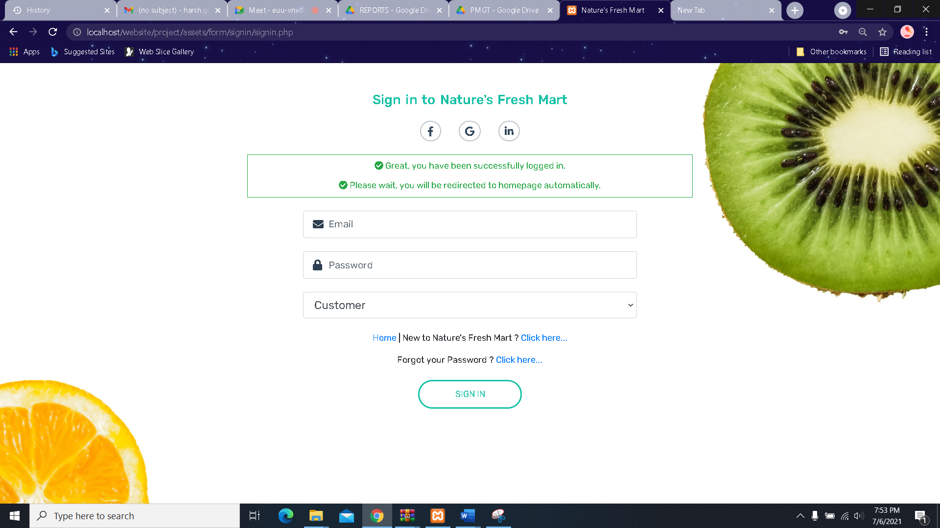

1. In the **Login page**, choose trader as your user type and login using your Invalid credentials

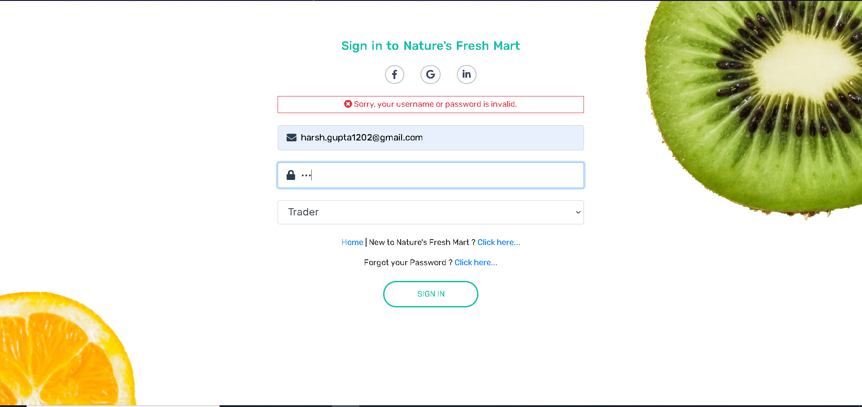

Empty Field

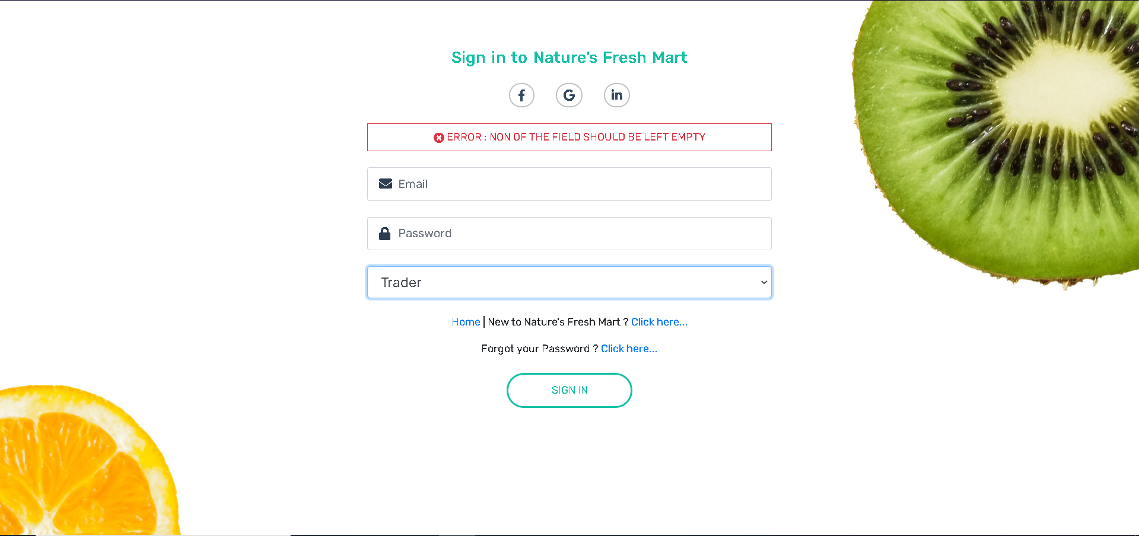

IF THE TRADER IS NOT REGISTERED, they can sign up the trader form as below:

Validations

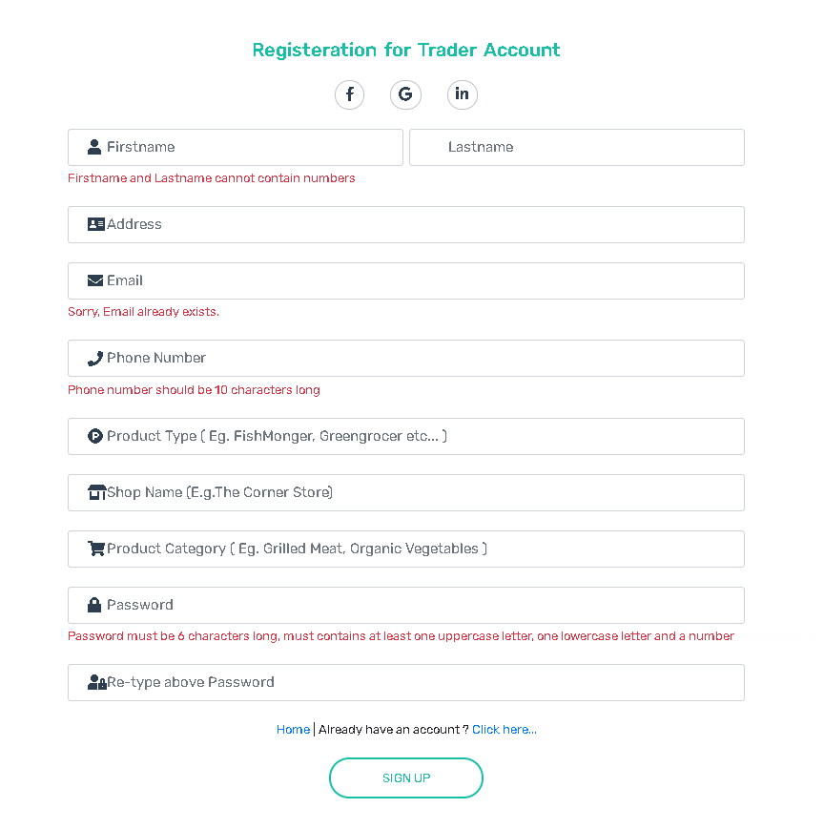

After Validation is met

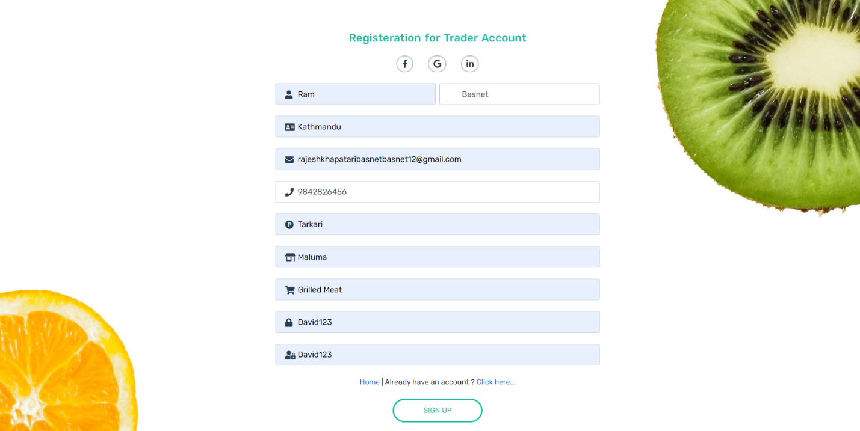

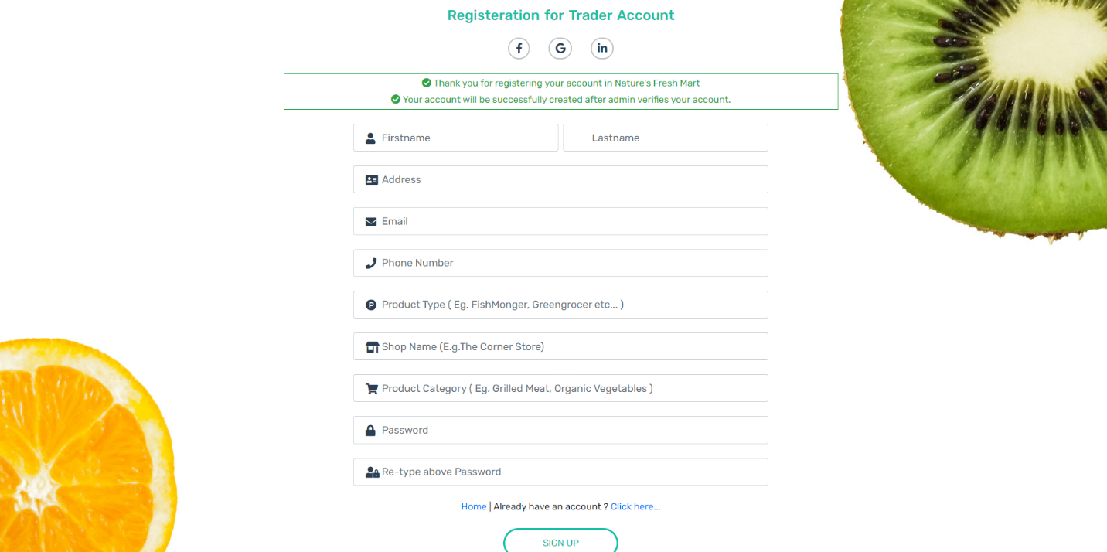

Empty Field

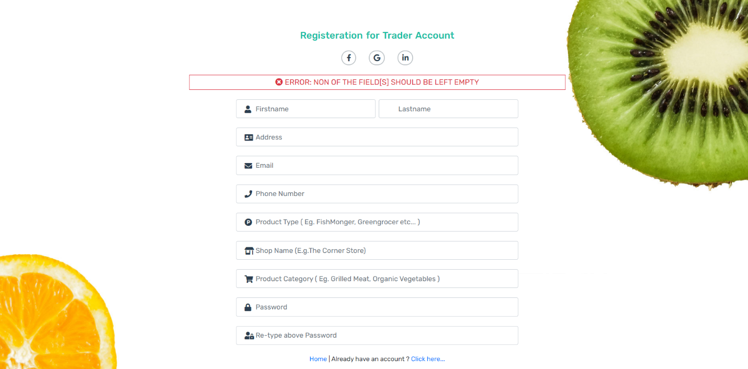

Email is sent to Admin for Verification

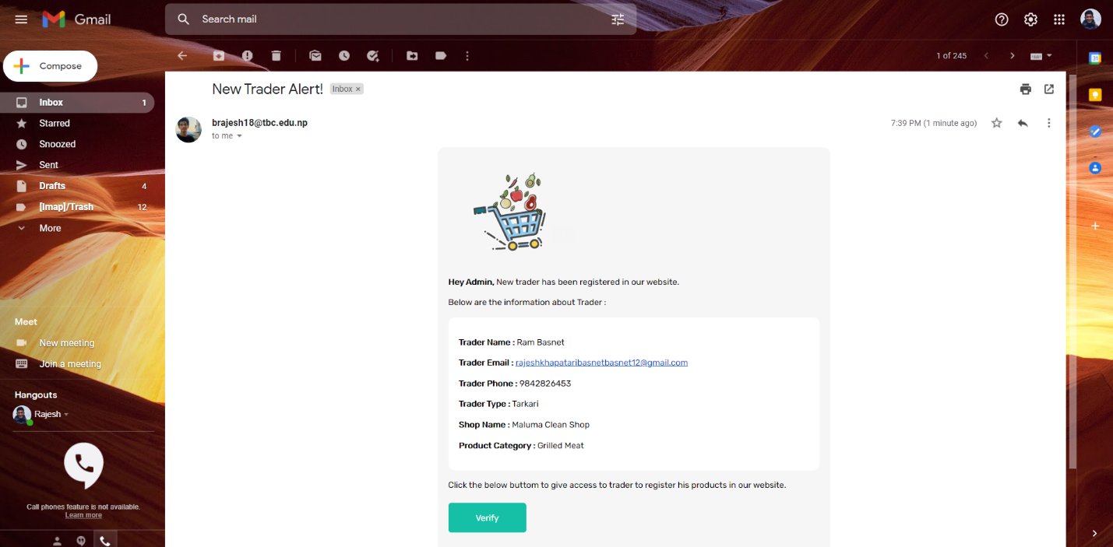

After Trader is verified, he receives email of confirmation.

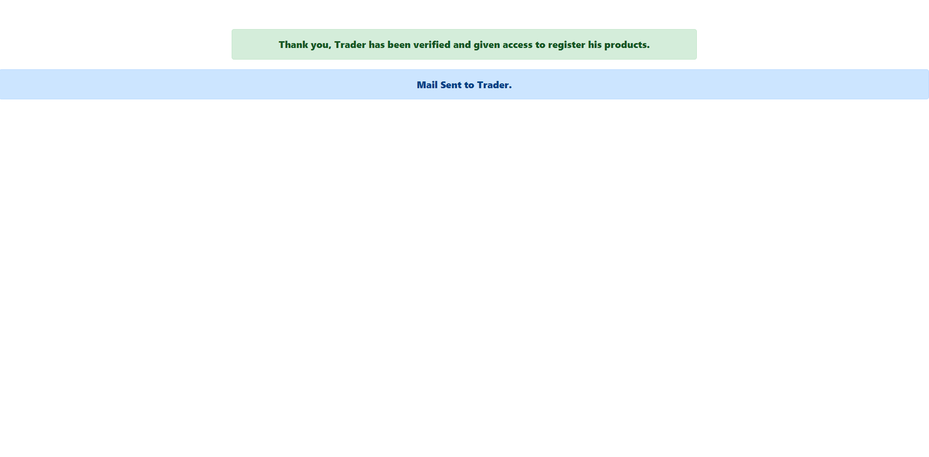

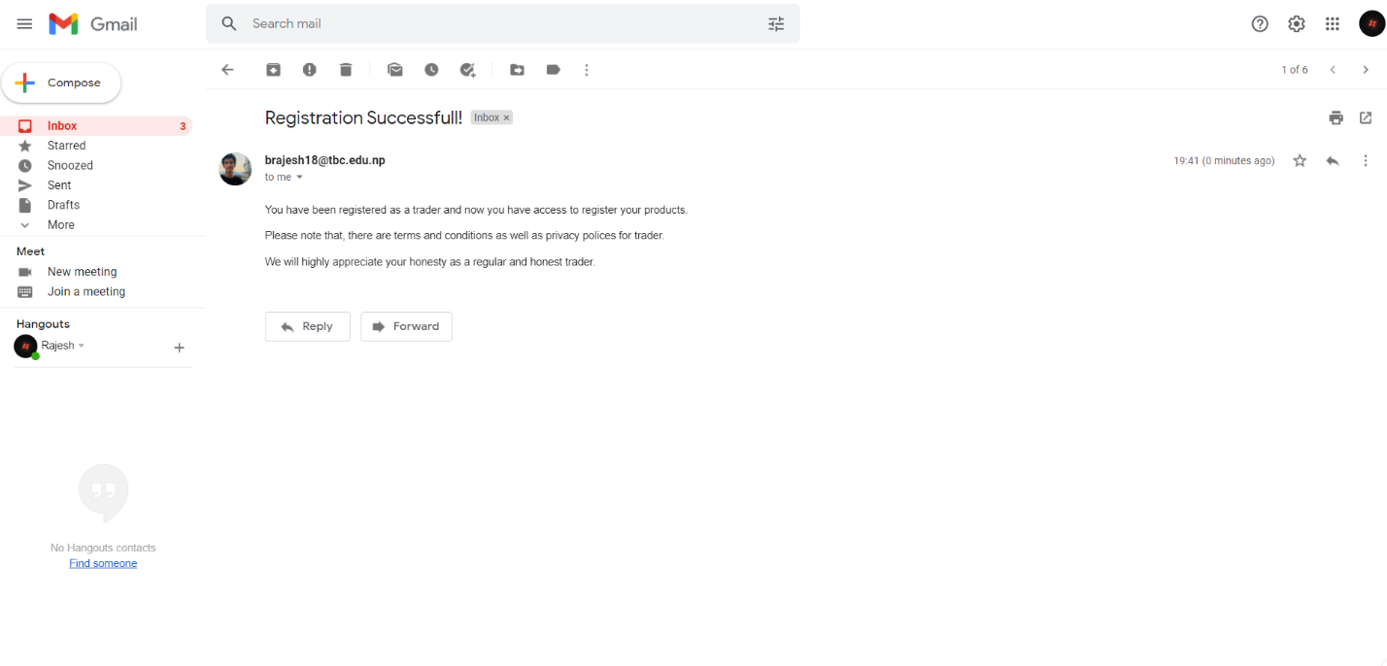

After Verification, we can see the trader listed in website

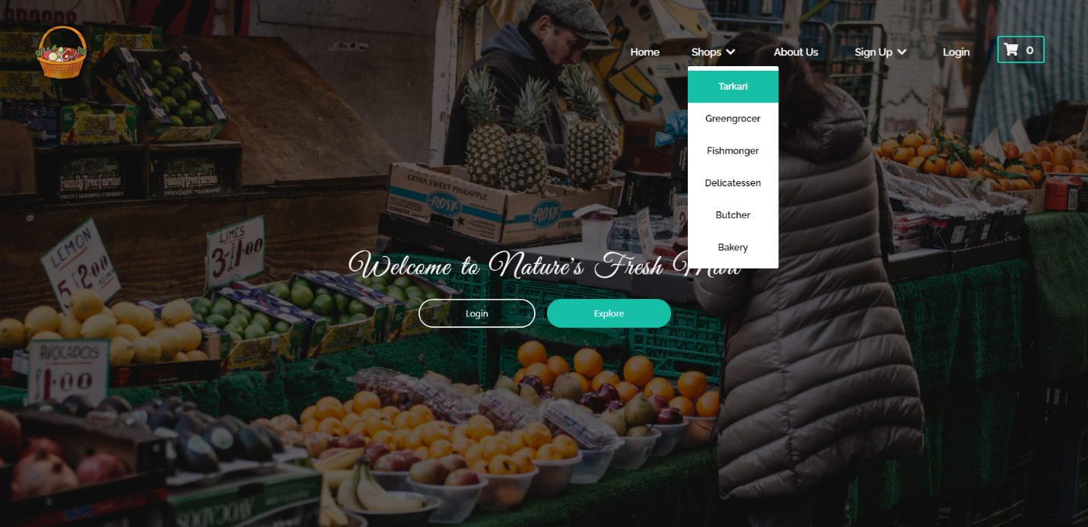

Sign UP Process ends, Trader will login after registered and add products as shown above from 1

1. Once the correct trader Login credentials are filled you will be redirected to the **homepage** from where you can access your **Trader Panel** by clicking the user icon in the navbar as displayed below

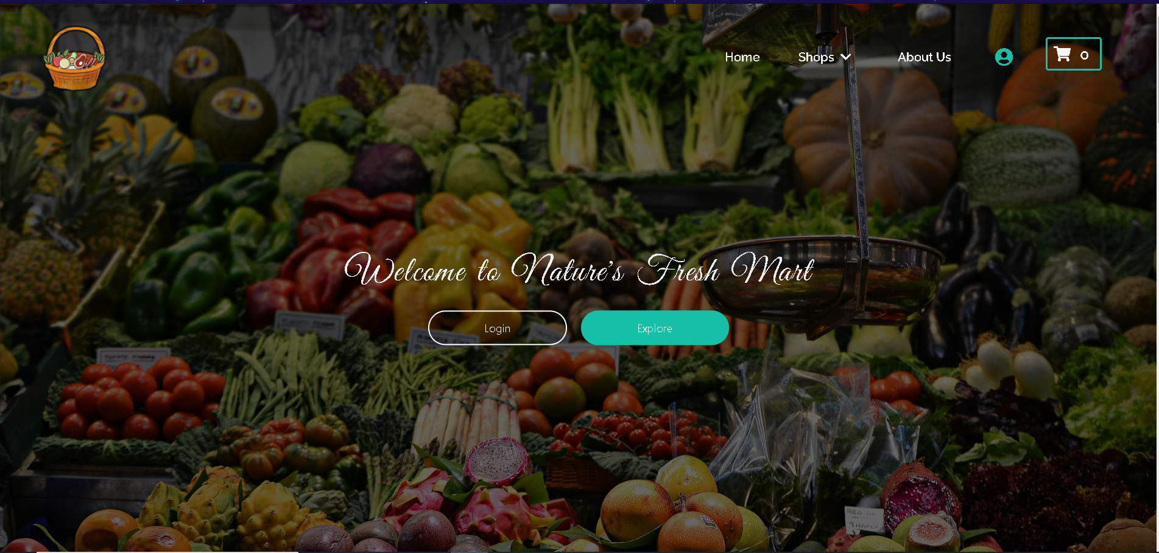

1. Once inside the **Trader Panel** you will end up in profile page where you can edit your details.

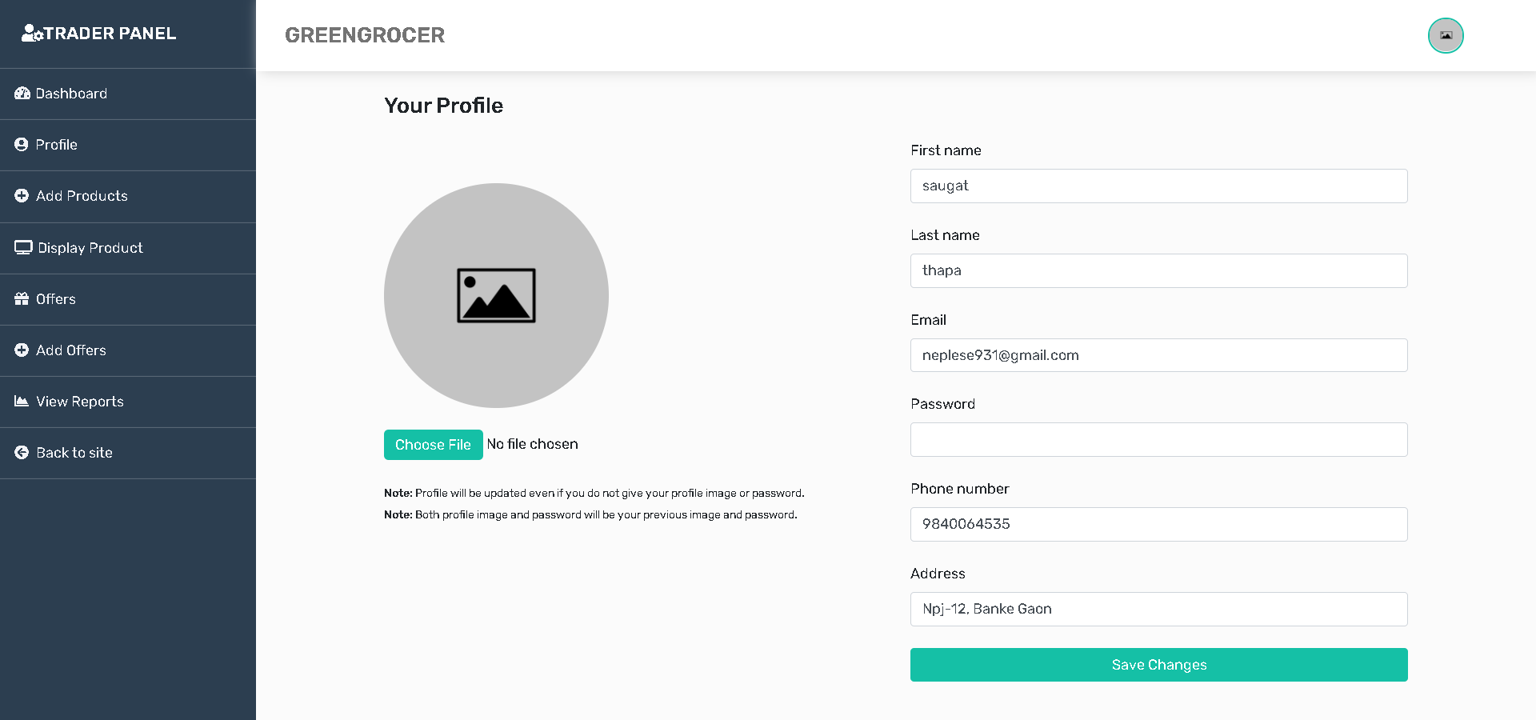

1. Trader will see the all the orders made to your shop by the customers inside dashboard.

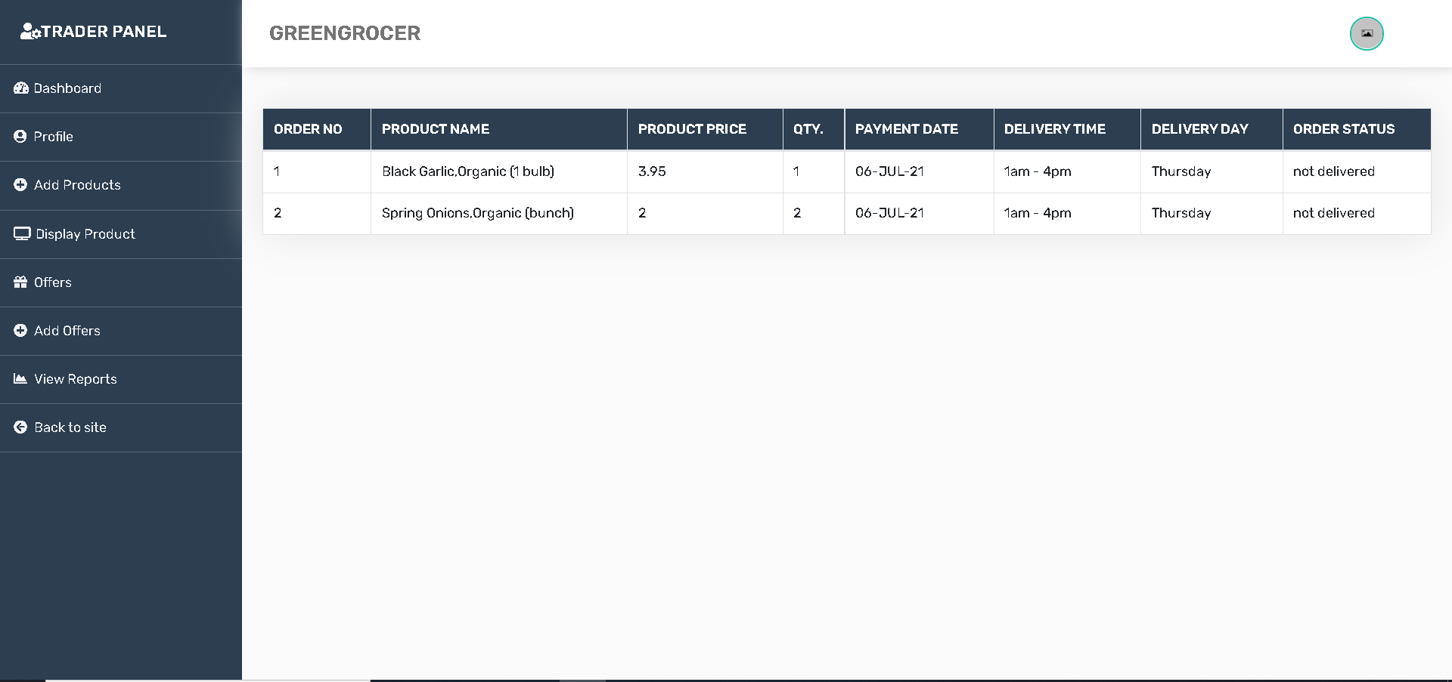

1. The second option you’ll see is the **Profile** section where you can update your personal information like your name, email, phone number and so on as shown above in 5 number.
2. After that, trader will be able to **Add Product** to their shop which looks like this

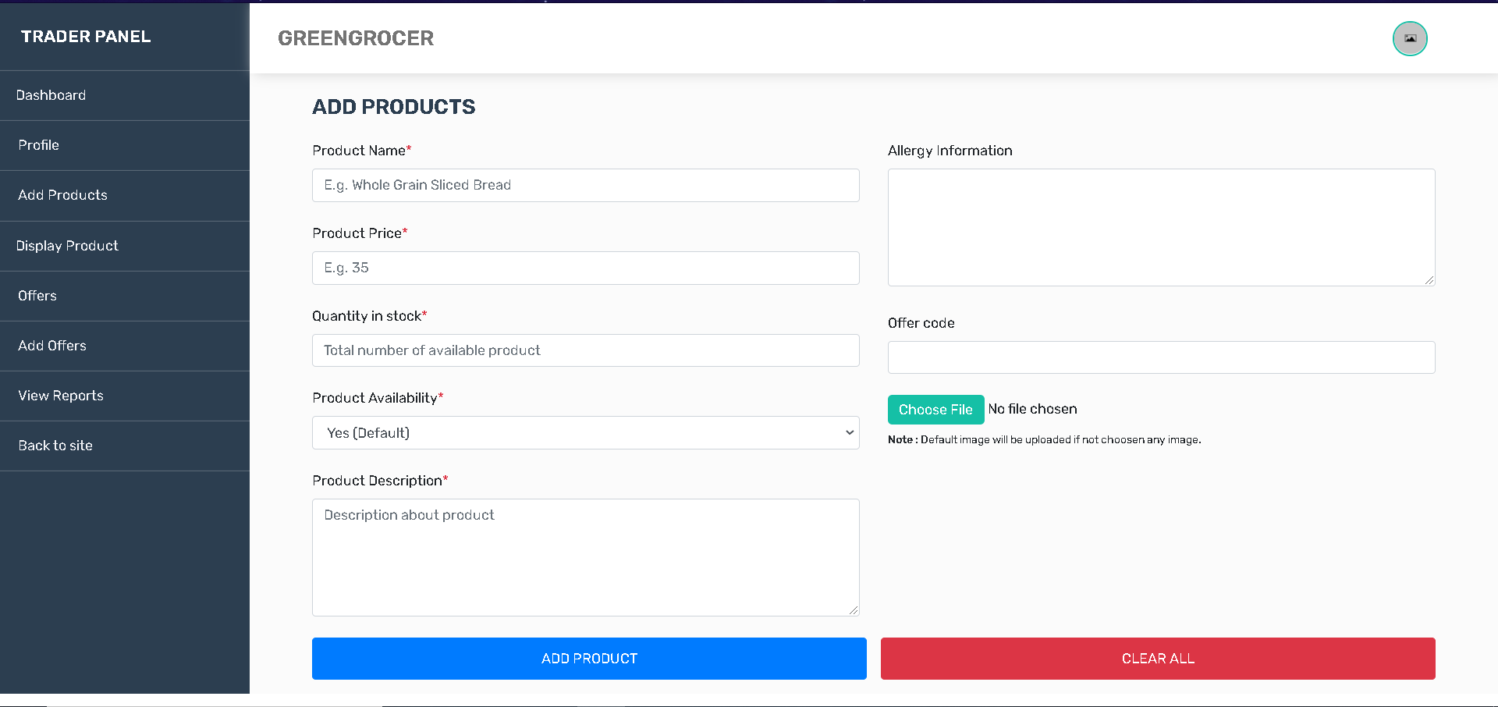

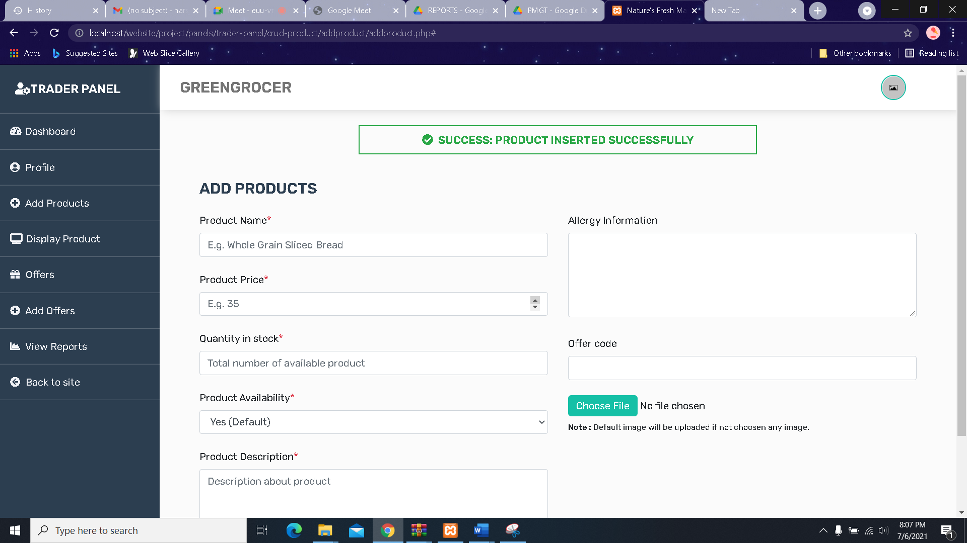

1. The next section is the **Display Product** section where trader can see all the products they’ve added till now and every information relating to those products and they can Delete or Update any product.

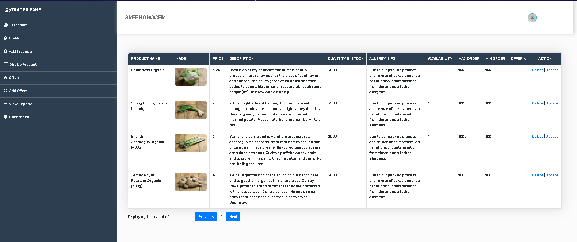

Delete Product

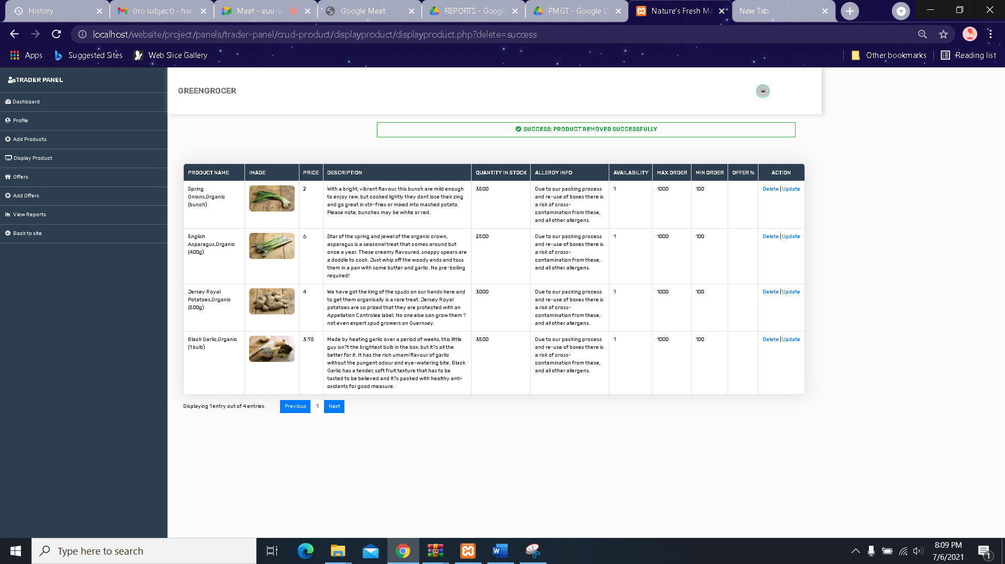

Update Product

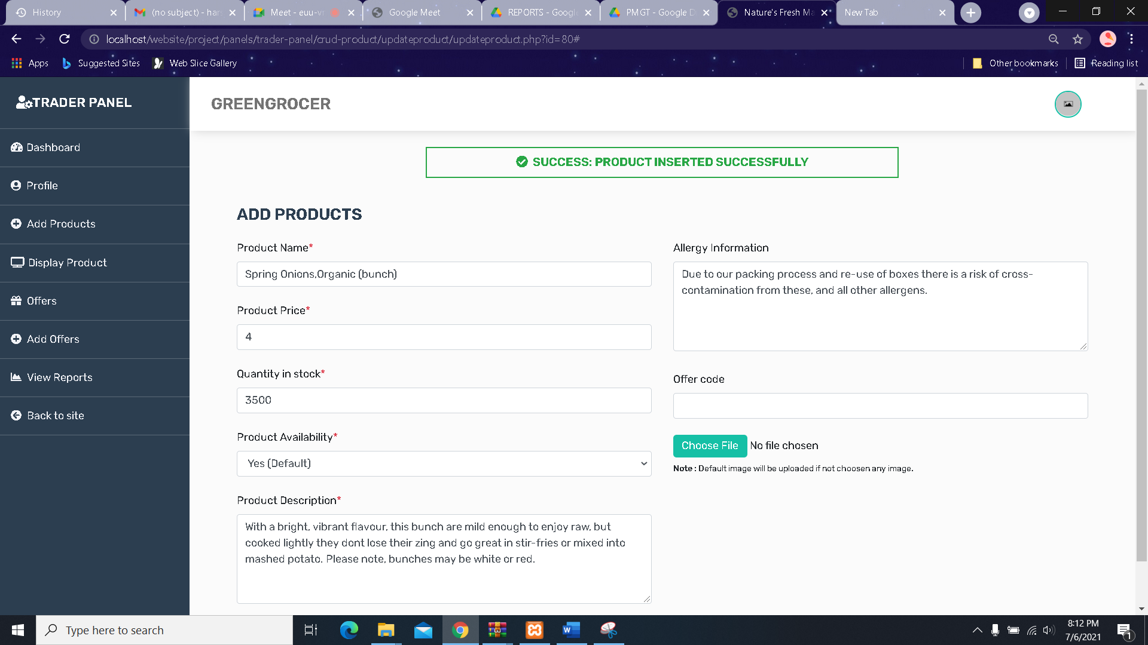

1. In the **Offers** section you can view all the offers your products may contain

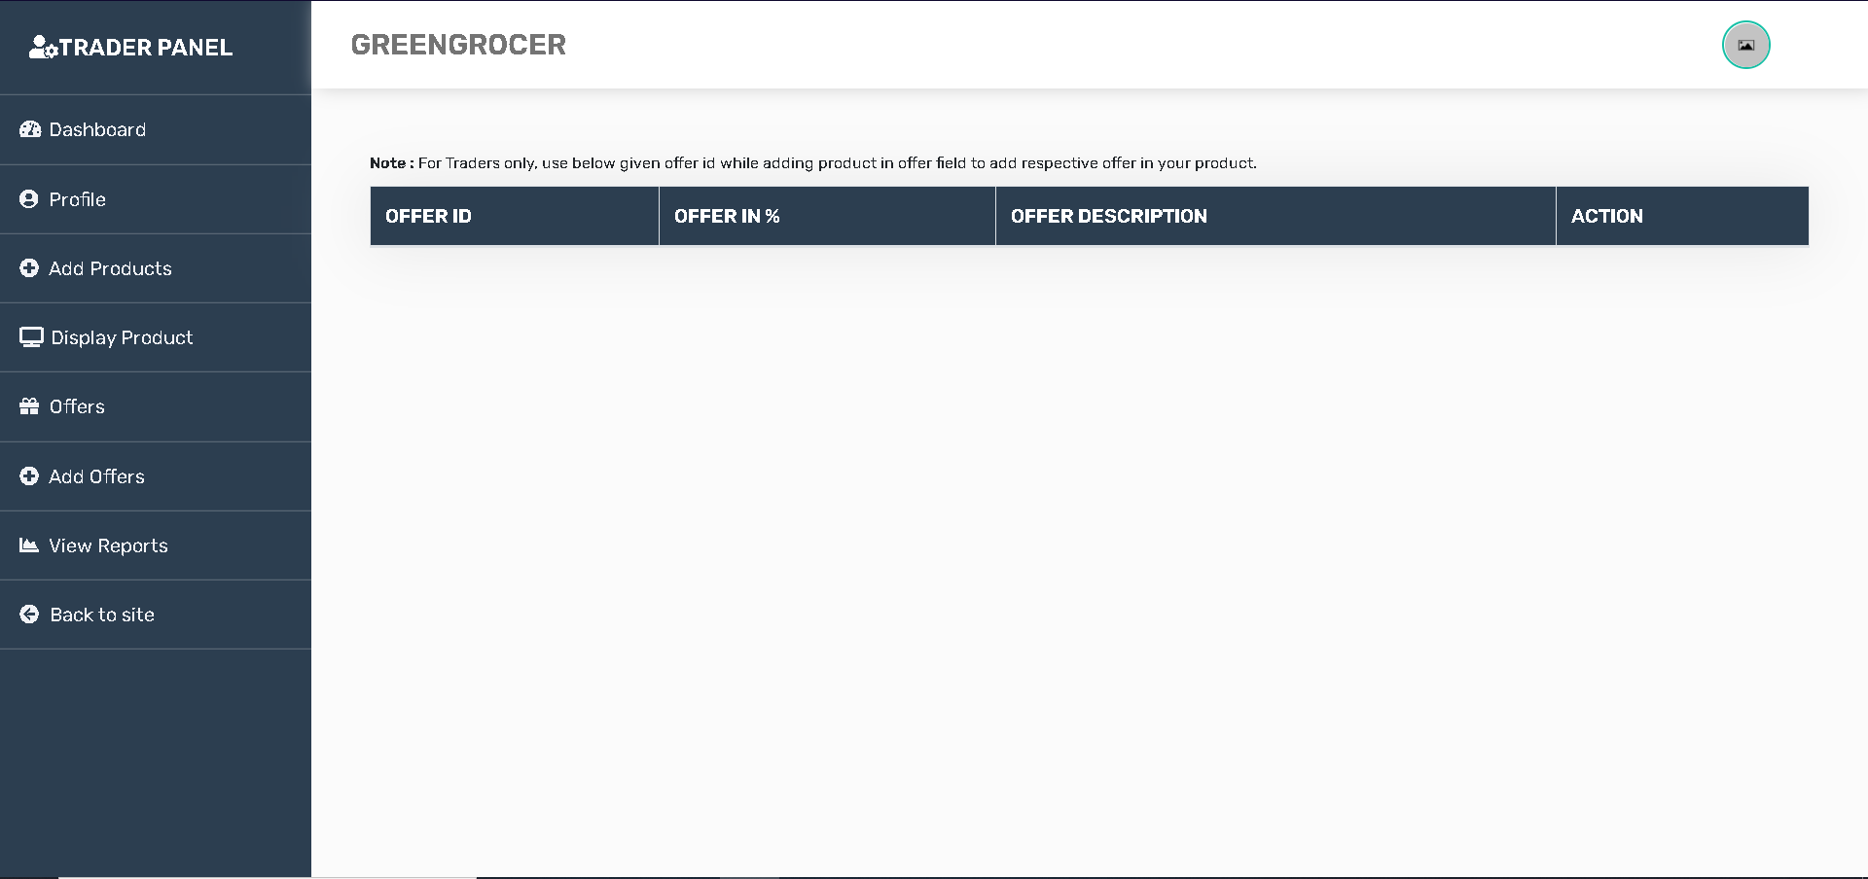

1. In the **Add Offers** section you can add new offers, set the offer percentage and provide a short description about the offers by filling out a simple form as shown below

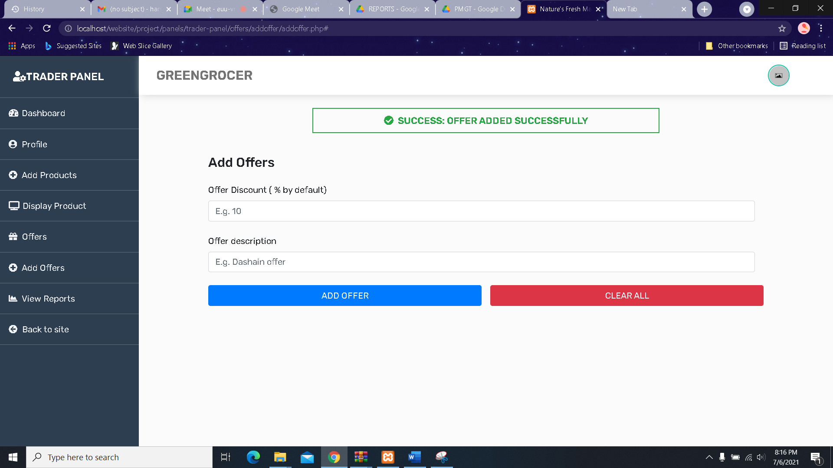

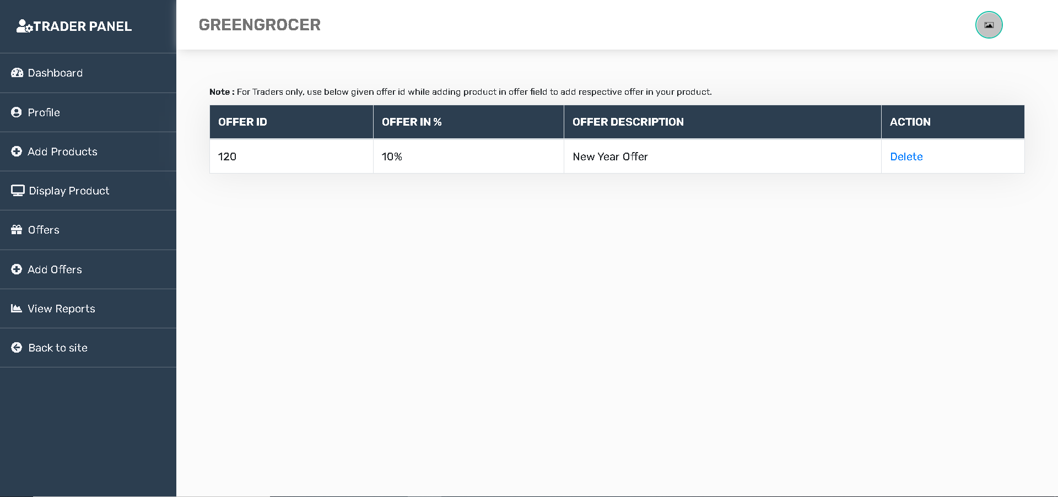

1. The next thing you’ll see is the **View Reports** button, when clicked will take you to the oracle application login page where after you login can view different reports.

* More Details in TRADER(ORACLE) file

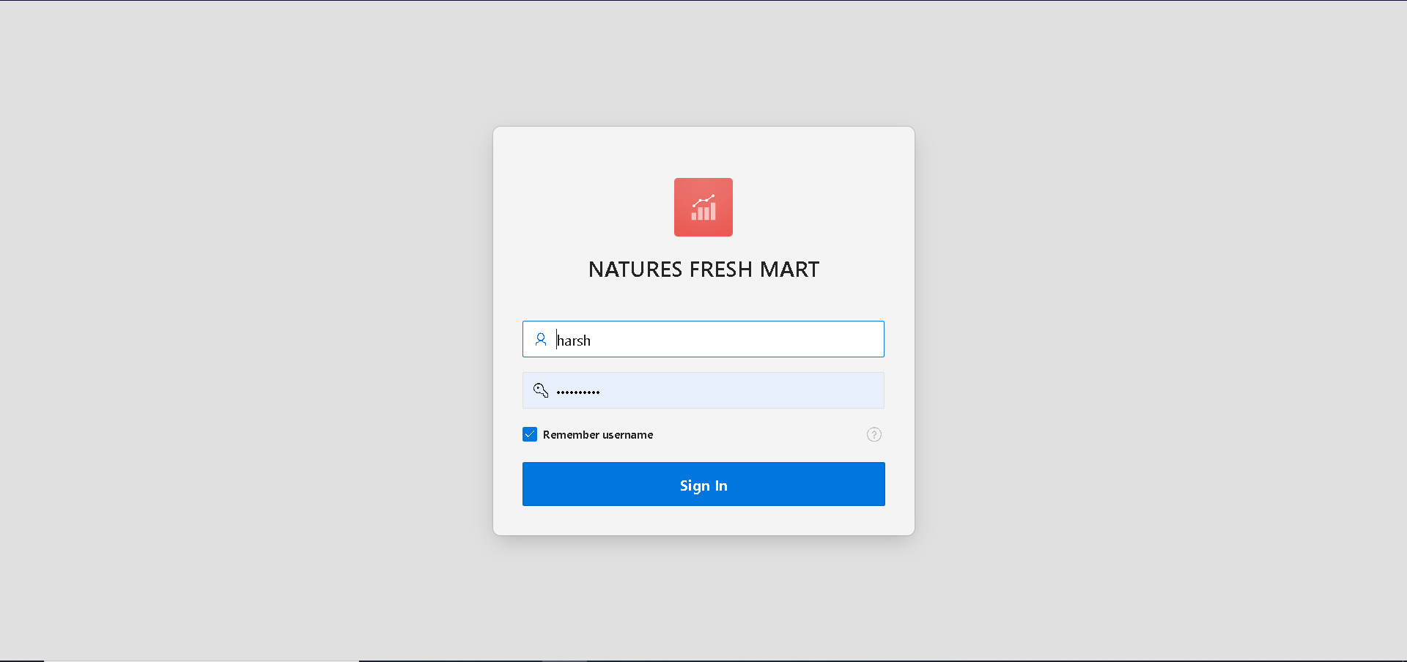

1. In order to L**ogout**, click the picture on the top right for **Logout** option.

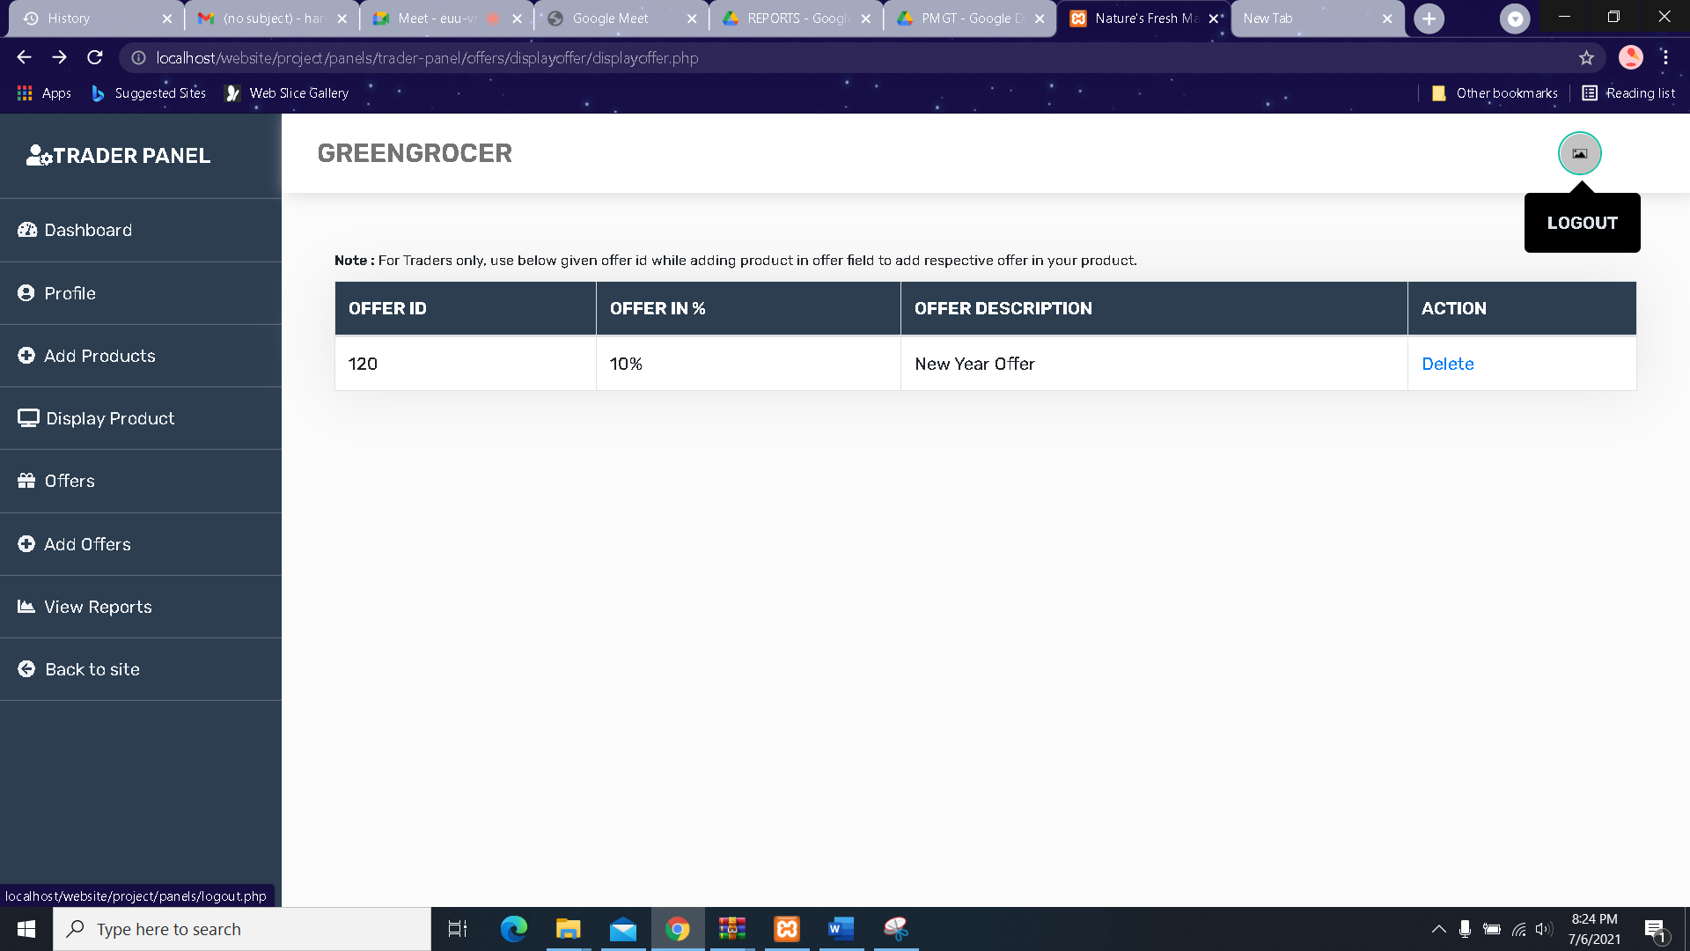

1. After Logout they will be directed to Homepage

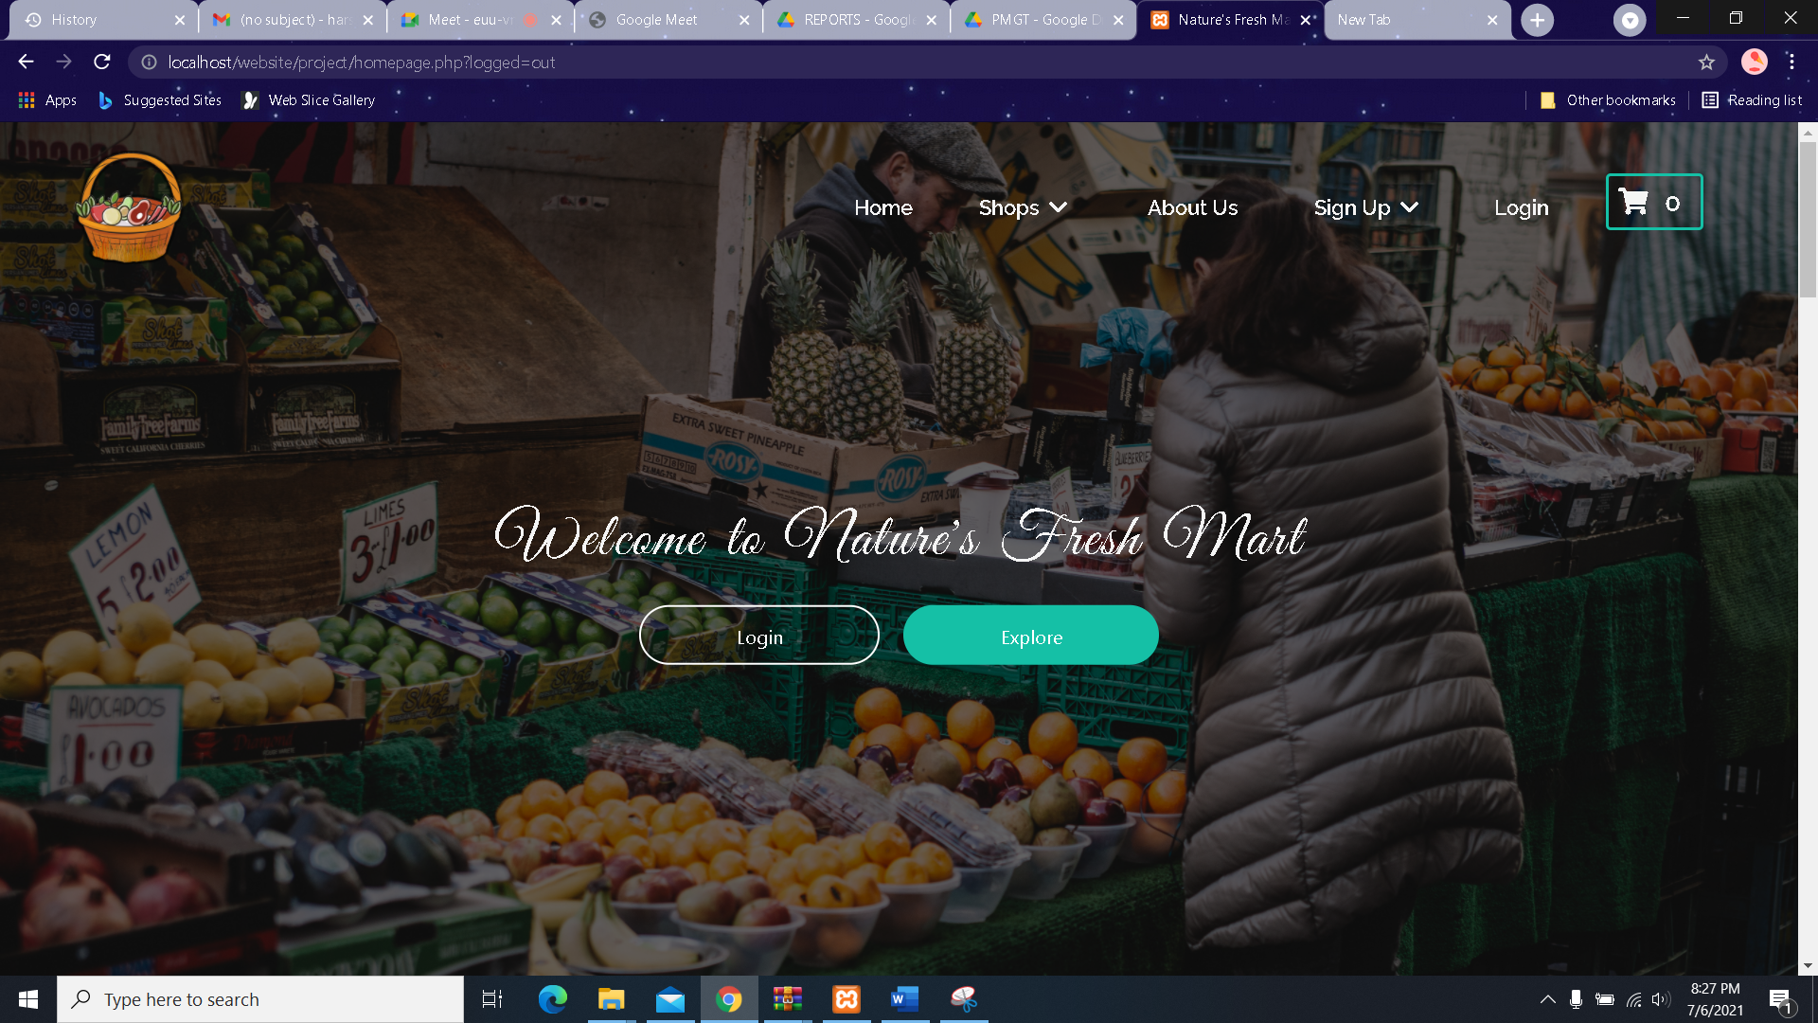

Thank You!